# SAUCEY

This was a very simple intro to web challenge, navigating to the webpage we are greeted with a very simple webpage. To get the flag you simply had to view the page source of the webpage.

You can right click on the page and hit page source and the flag is in a comment.

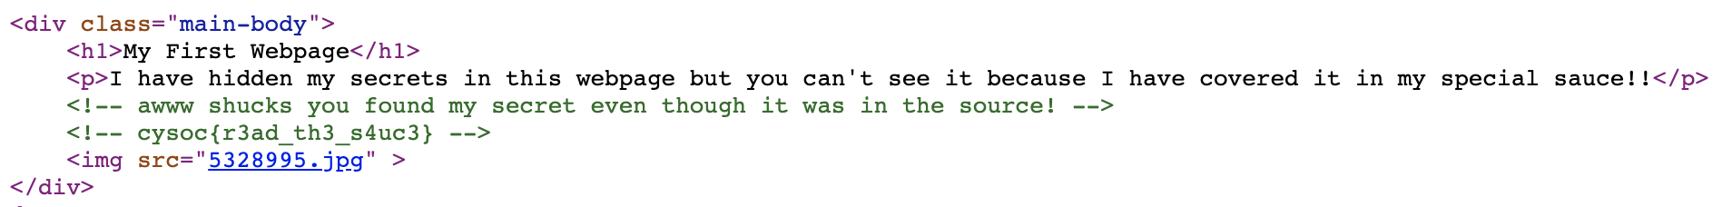

Which gives the flag:  
cysoc{r3ad_th3_s4uc3}